^{3rd} Edition
The
VIEW
CRESCENT HILL

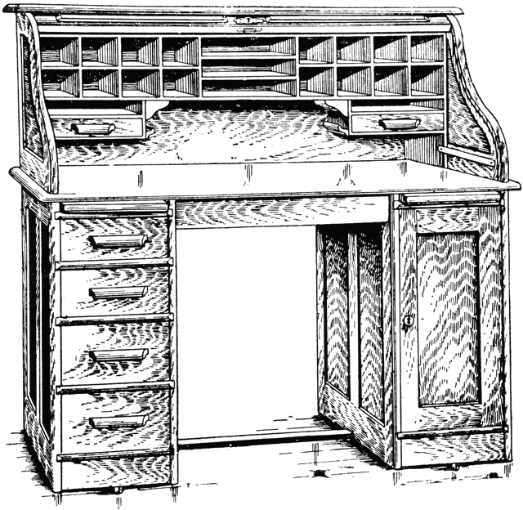
The Pastor's Desk

Have you ever given any thought to how many things you have memorized? PIN numbers, Social Security Number, computer passwords, bank account numbers, etc. . . . We all memorize things that are important to us and that we may need available at a moment's notice. How many things did you memorize in school that you still remember. I'm sure you don't remember everything, maybe not even half, but you would be surprised how much you do remember. Things like the names of Presidents, state capitals, Periodic Table of Elements. . . . Think about how many of those things you do remember.
You see, we often excuse ourselves from the hard work of memorizing Scripture by saying that we can't memorize or that we will just forget most of what we memorize, yet we are able to memorize other things because they are important and we use them frequently. Shouldn't we describe Scripture in the same way? It's the most important information in our lives, we often need it in a moment's notice, and we ought to use it often in our witnessing encounters, as we encourage one another and when we battle Satan. Remember, he is your enemy, and without your sword, you have no chance.
The longest chapter in the Bible, Psalm 119, is dedicated to the praise of God's Word. We are encouraged throughout Scripture to dwell upon, keep, meditate on, and hide God's Word in our hearts. If we do, the rewards are far greater than anything this world has to offer. With this is mind, I encourage each one of you to join together in the corporate memorization of the Bible. As a church, we are going to memorize a couple of verses each week together. I don't have a practical way to hold you accountable to this task, but I ask you to covenant with your church family and God to journey this road of memorization.
Check the bulletin each week for the verses to be memorized that week. For the month of June, we will memorize Psalm 1 and integrate it into our weekly gathering for the glory of God!


Vacation Bible School

Vacation Bible School will soon be upon us and we need the help of each one of you! Each week from now until VBS week, VBS volunteers will meet to plan and strategize for this important week for our church and community.
Vacation Bible School will be July 19 through the 24th with commencement being on July 26. Perhaps you won't be available all of those night, or may you won't be available at all during VBS, but we still need your help to mail out fliers, make door-to-door visitation, and plan. Through the years, God has used VBS in His churches to convert and disciples youth as well as develop and grow churches. Please join together in praying for those who will be serving as well as those who will attend. May God be glorified and our community served!

Doodle Trail Outreach

The cities of Pickens and Easley have recently completed the Doodle Trail, a trail for walking, running, and biking. The Swamp Rabbit Trail in Greenville, which inspired the creation of the Doodle Trail, has had an incredible impact on the community and local business in Travelers Rest. It is anticipated that the Doodle Trail will have a similar impact on Pickens, and our church should take advantage of this opportunity for community outreach, but we need your ideas!
Do you know someone whose property backs up to the trail that might allow us to set up a pop-up canopy a few times during the warm months? We could use this as a base to hand out water, church information and
continued. . .
Gospel tracts to walkers and bicyclist as they pass by. Maybe you have a different idea of how we can have a presence on the trail. All ideas are welcome! Please talk to Pastor Ross if you have any ideas!

Community Youth Outreach

There will be several opportunities each month to involve the young people in our community in church. On the 1st and 3rd Sunday nights of each month, there will be an activity in the basement under the worship center (we are going to call this area for youth the “Root Cellar”) to engage our young people in a fun activity and then have them stay with us for Sunday evening worship. On the 1st Sunday night of each month, the youth drama team will meet and on the 3rd Sunday night of each month, the radio controlled truck and track will be set up.


Church Notes

Kayla and I would like to thank you all for the party you gave us for our birthdays and for your generous gifts. We love being able to share these events with you. May God continue to bless each of you! – Pastor Ross

Nursery is available for each Sunday service and Wednesday night Bible Study. If you can volunteer to help with this ministry, please see Pastor Ross.

Gospel tracts are available in the church vestibule and are free for your use. Please take advantage of these resources as we participate in the Great Commission together

Counters for the month of June are Pete and Jean Masters.

Join us in welcoming Nicholas, Kaelynn, Leviticus, and Noah Watson to our church family. Be sure to let them know you are glad they are a part of our family and that you are praying for them!

On the Bookshelf

Recommended reading for the month of June:

God's Battle Plan for the Mind by David Saxton
An Approach to Extended Memorization of Scripture by Andrew Davis
Alone with God by John MacArthur
Finally Free by Heath Lambert
Crescent Hill Baptist Church

Go. Grow. Glorify.

111 Crescent Hill Drive (864) 878 3966
Pickens, SC 29671

Visit us online @ www.chbcpickens.org You can also find us on Twitter and Facebook!

Service Times

Sunday School . . . . . . . . . . . . . . . . . . . . . . . . . . . . 9:45
Sunday Morning Worship. . . . . . . . . . . . . . . . . . 11:00
Sunday Evening Worship. . . . . . . . . . . . . . . . . . . . 6:00

Wednesday Evening Bible Study. . . . . . . . . . . . . . 7:00

We observe the sacrament of the Lord's Supper on the 1st Sunday morning of each month.

We meet for church member's meeting on the 3rd Wednesday night of each month.

Serving God's Church

Pastor . . . . . . . . . . . . . . . . . . . . . . . . . . . . . .Ross Estep
(864) 616 0210
estep.ross@gmail.com

Deacons . . . . . . . . . . . . . . . . . . . . . . . . . . . . Bill Collins
Pete Masters
Bill Ward

Assistant . . . . . . . . . . . . . . . . . . . . . . . LaVerne Moore
crescenthil15865@bellsouth.net

Music Director . . . . . . . . . . . . . . . . . . Miriam Waldrop

Children/Youth Directors . . . . . . . . . . . Phillip Farmer
Brian Keeler

Nursery Workers . . . . . . . . . . . . . . . . . . Martha Leslie
April Keeler
Charlene Crenshaw
Rheba Simmons

Instrumentalists . . . . . . . . . . . . . . . . .Betty Crenshaw
Austin Tinsley
Thomas Ward

Audio/Video Technician . . . . . . . . . . . . . . . . Bill Ward

Custodians . . . . . . . . . . . . . . . . . . . . . . . Thomas Ward
Elizabeth Ward
Hannah Ward

